MENTAL HEALTH ASSISTANT USING MACHINE LEARNING

Internship Project Report

Intern Details
Intern Name : Kaniyamuthu B
Intern ID : CITS862
Internship Domain : Artificial Intelligence
Project Title : Mental Health Assistant Using
Machine Learning.
Duration : 6 Weeks

1. Abstract
Mental health plays an important role in a person's overall well-being. This project aims to develop a simple Mental Health Assistant using Machine Learning. The assistant identifies a user's emotional state based on text input and provides appropriate suggestions or advice. The project demonstrates how Artificial Intelligence can be used to support mental well-being through basic conversational assistance.

2. Introduction
People experience different emotions such as happiness, stress, anxiety, and sadness in their daily lives. Sometimes individuals may benefit from simple guidance and positive suggestions. A Mental Health Assistant can provide supportive responses based on a user's feelings.
This project uses Machine Learning techniques to recognize emotional keywords and generate suitable advice.

3. Objectives
- To develop a simple Mental Health Assistant.
- To identify emotions from user input.
- To provide supportive suggestions.
- To demonstrate the application of AI in mental health support.
- To improve understanding of machine learning classification.

4. Tools and Technologies Used
- Python
- Google Colab
- Pandas
- Scikit-Learn
- CountVectorizer
- K-Nearest Neighbors (KNN)

5. Methodology

Step 1: Data Collection
A dataset containing emotions and corresponding advice was created.

Step 2: Data Preparation
The dataset was organized into a structured format using Pandas.

Step 3: Feature Extraction
Text inputs were converted into numerical representations using CountVectorizer.

Step 4: Model Training
A K-Nearest Neighbors (KNN) classifier was trained on the dataset.

Step 5: Prediction
The model predicted suitable advice based on the user's emotional input.

6. Screenshots
Dataset Output:
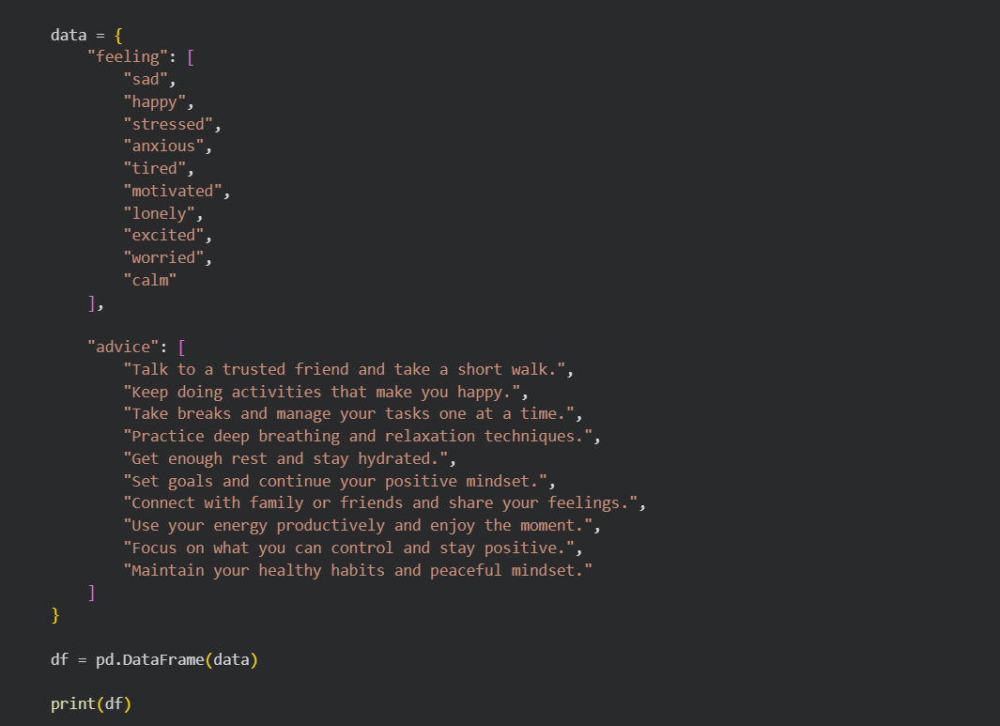
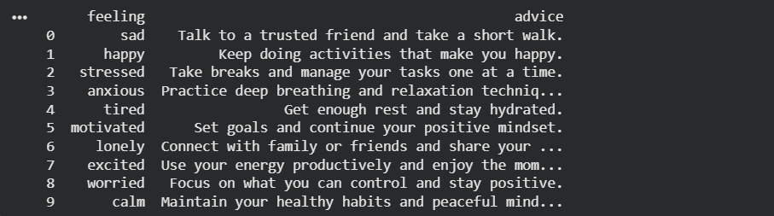

Model Training Output:
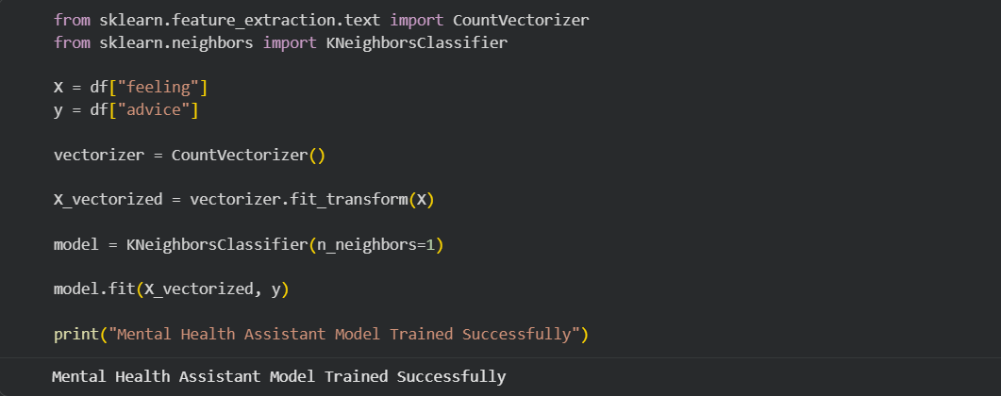
Prediction for "sad":
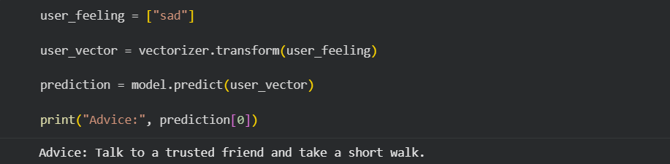

Prediction for "stressed":
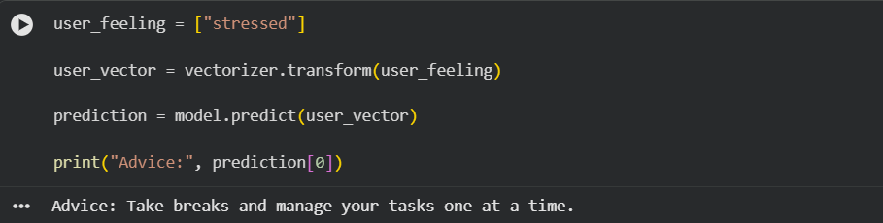

Interactive User Input Output:
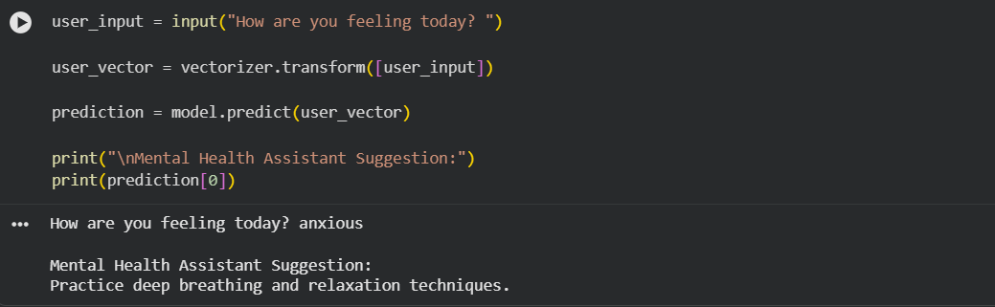

Project Completion Output:

7. Implementation
- Importing libraries.
- Creating the dataset.
- Vectorizing text inputs.
- Training the KNN model.
- Accepting user input.
- Generating mental health suggestions.

8. Future Enhancements
- Add more emotions and responses.
- Integrate chatbot functionality.
- Support voice input.
- Use advanced NLP and Deep Learning models.
- Develop a web or mobile application.

9. Conclusion
The Mental Health Assistant project successfully demonstrates the use of Artificial Intelligence and Machine Learning to recognize emotional states and provide supportive suggestions. The project highlights how AI can be used to create helpful and accessible tools for daily well-being.

References
- Python Documentation
- Pandas Documentation
- Scikit-Learn Documentation
- Google Colab Documentation
- Machine Learning Fundamentals

